Story of an Organization LT

* LT is an organization who is developing an application for health care. Big Hospital chains are their customers 1) Apollo 2) Fortis and 3) AIG
* Architecture of their application  
  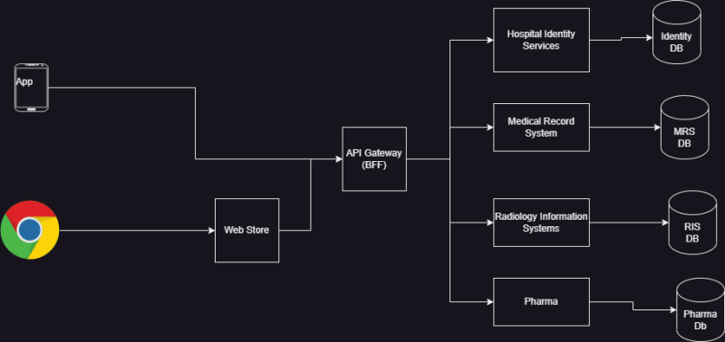
* To develop this application, we have one team per service
* To test this application, we have
  + automated testers
  + manual testers
* Goals: LT want to implement DevOps Practices
  + Check the code quality and regressions whenever developer commits the code.
  + Manual testers will test all the work done by developers’ previous day in today’s work
  + Code Quality has to be tested by Static Code Analysis tools
  + We need to store the build artifacts of night build in artifact repository

Terms

* Regression: New changes impacting working features and tests to identify this are called as Regression tests
* API Testing:
* Rest API
* unit testing: testing smaller units of code by writing code
* Day build: Every change submitted by developer during active work hours
  + We do minimal test executions
  + This should finish quickly
* night build: This build is done to consolidate all the work done by your dev team for the whole day
  + We do execute all the automated tests
  + This might take hours and gives confidence to manual testing team so that they can consider this build
* Quality Gate: If we fail the build when code quality issues exist this is called as Quality Gate
* Artifact: Artifact is what build/package generates
* Repository: This is a storage location which maintains history

Day build and Night build: A daily build or nightly build is the practice of completing a [software build](https://en.wikipedia.org/wiki/Software_build) of the latest version of a program, on a daily basis. This is so it can first be [compiled](https://en.wikipedia.org/wiki/Compiler) to ensure that all required dependencies are present, and possibly tested to show no [bugs](https://en.wikipedia.org/wiki/Computer_bug) have been introduced. The daily build is also often publicly available allowing access to the latest features for feedback. In this context a *build* is the result of [compiling](https://en.wikipedia.org/wiki/Compiler) and [linking](https://en.wikipedia.org/wiki/Linker_(computing)) all the files that make up a [program](https://en.wikipedia.org/wiki/Computer_program). The use of such disciplined procedures as daily builds is particularly necessary in large organizations where many programmers are working on a single piece of software. Performing daily builds helps ensure that [developers](https://en.wikipedia.org/wiki/Software_developer) can work knowing with reasonable certainty that any new bugs that show up are a result of their own work done within the last day.

Daily builds typically include a set of tests, sometimes called a "[smoke test](https://en.wikipedia.org/wiki/Smoke_testing_(software))." These tests are included to assist in determining what may have been broken by the changes included in the latest build. The critical piece of this process is to include new and revised tests as the project progresses.

Day build: for Developer, Night build for release.

Artifactory: Artifactory is a branded term to refer to a repository manager that organizes all of your binary resources. These resources can include remote artifacts, proprietary libraries, and other third-party resources. A repository manager pulls all of these resources into a single location.